Phase-3 421221106006

Project Title – Air Quality Monitoring using IOT

**Steps for Coding:**

1. Connect the sensors to a microcontroller or single-board computer like Arduino or Raspberry Pi.

2. Use libraries or APIs provided by the sensor manufacturers to read data from the sensors.

3. Store the sensor data in a database or a file for further analysis.

4. Apply data processing techniques to clean and normalize the data.

5. Use programming languages like Python or R to analyze the data, calculate air quality indices, and generate visualizations.

6. Implement real-time monitoring by continuously collecting and processing data.

7. Display the air quality information on a web page or a mobile app for easy access.

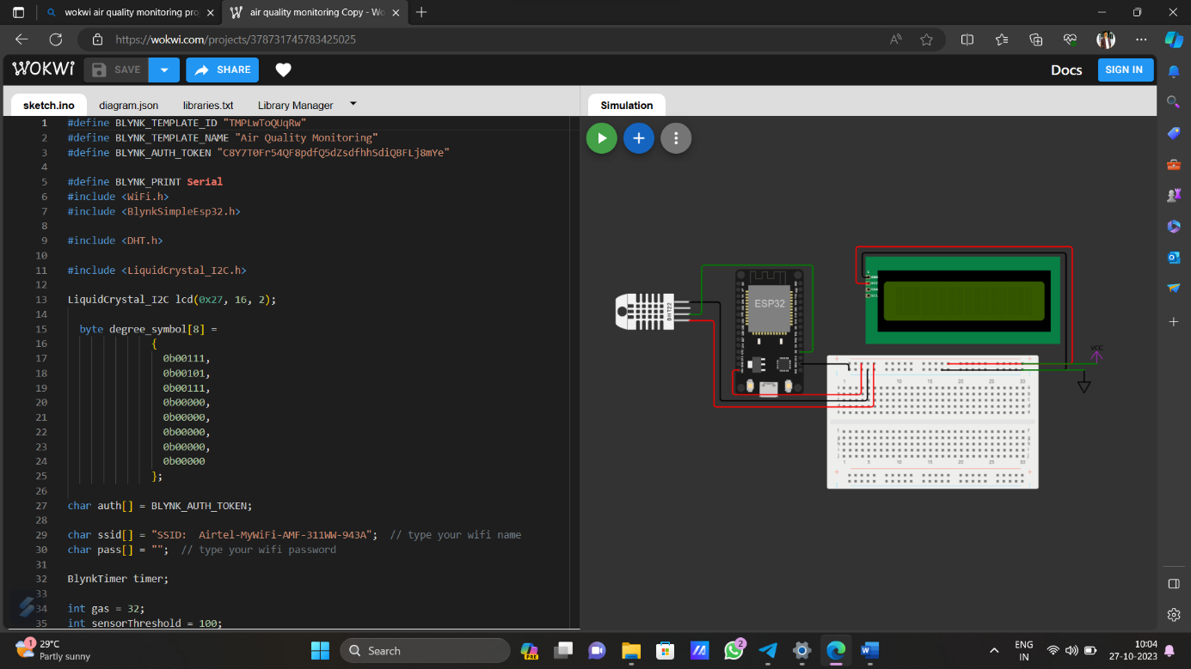

**Program C coding:**

#define BLYNK_TEMPLATE_ID "TMPLwToQUqRw"

#define BLYNK_TEMPLATE_NAME "Air Quality Monitoring"

#define BLYNK_AUTH_TOKEN "C8Y7T0Fr54QF8pdfQ5dZsdfhhSdiQBFLj8mYe"

#define BLYNK_PRINT Serial

#include <WiFi.h>

#include <BlynkSimpleEsp32.h>

#include <DHT.h>

#include <LiquidCrystal_I2C.h>

LiquidCrystal_I2C lcd(0x27, 16, 2);

byte degree_symbol[8] =

{

0b00111,

0b00101,

0b00111,

0b00000,

0b00000,

0b00000,

0b00000,

0b00000

};

char auth[] = BLYNK_AUTH_TOKEN;

char ssid[] = "SSID: Airtel-MyWiFi-AMF-311WW-943A"; // type your wifi name

char pass[] = ""; // type your wifi password

BlynkTimer timer;

int gas = 32;

int sensorThreshold = 100;

#define DHTPIN 2 //Connect Out pin to D2 in NODE MCU

#define DHTTYPE DHT11

DHT dht(DHTPIN, DHTTYPE);

void sendSensor()

{

float h = dht.readHumidity();

float t = dht.readTemperature(); // or dht.readTemperature(true) for Fahrenheit

if (isnan(h) || isnan(t)) {

Serial.println("Failed to read from DHT sensor!");

return;

}

int analogSensor = analogRead(gas);

Blynk.virtualWrite(V2, analogSensor);

Serial.print("Gas Value: ");

Serial.println(analogSensor);

// You can send any value at any time.

// Please don't send more that 10 values per second.

Blynk.virtualWrite(V0, t);

Blynk.virtualWrite(V1, h);

Serial.print("Temperature : ");

Serial.print(t);

Serial.print(" Humidity : ");

Serial.println(h);

}

void setup()

{

Serial.begin(115200);

//pinMode(gas, INPUT);

Blynk.begin(auth, ssid, pass);

dht.begin();

timer.setInterval(30000L, sendSensor);

//Wire.begin();

lcd.begin(16,2);

// lcd.backlight();

// lcd.clear();

lcd.setCursor(3,0);

lcd.print("Air Quality");

lcd.setCursor(3,1);

lcd.print("Monitoring");

delay(2000);

lcd.clear();

}

void loop()

{

Blynk.run();

timer.run();

float h = dht.readHumidity();

float t = dht.readTemperature(); // or dht.readTemperature(true) for Fahrenheit

int gasValue = analogRead(gas);

lcd.setCursor(0,0);

lcd.print("Temperature ");

lcd.setCursor(0,1);

lcd.print(t);

lcd.setCursor(6,1);

lcd.write(1);

lcd.createChar(1, degree_symbol);

lcd.setCursor(7,1);

lcd.print("C");

delay(4000);

lcd.clear();

lcd.setCursor(0, 0);

lcd.print("Humidity ");

lcd.print(h);

lcd.print("%");

delay(4000);

lcd.clear();

//lcd.setCursor(0,0);

// lcd.print(gasValue);

// lcd.clear();

Serial.println("Gas Value");

Serial.println(gasValue);

if(gasValue<1200)

{

lcd.setCursor(0,0);

lcd.print("Gas Value: ");

lcd.print(gasValue);

lcd.setCursor(0, 1);

lcd.print("Fresh Air");

Serial.println("Fresh Air");

delay(4000);

lcd.clear();

}

else if(gasValue>1200)

{

lcd.setCursor(0,0);

lcd.print(gasValue);

lcd.setCursor(0, 1);

lcd.print("Bad Air");

Serial.println("Bad Air");

delay(4000);

lcd.clear();

}

if(gasValue > 1200){

//Blynk.email("shameer50@gmail.com", "Alert", "Bad Air!");

Blynk.logEvent("pollution_alert","Bad Air");

}

}